LAB 1: Introduction to XML
Objective:
- To understand the purpose and structure of XML.
Steps:
- Open a text editor.
- Start with an XML declaration.
- Create a basic XML structure with elements.
- Save the file with a .xml extension.
- Open the file in a browser or XML viewer.
Source Code:
<?xml version="1.0" encoding="UTF-8"?>
<message>
<sender>Kusum Darlami</sender>
<receiver>SuzanYba</receiver>
<text>Hello, this is a test message!</text>
</message>
Output:
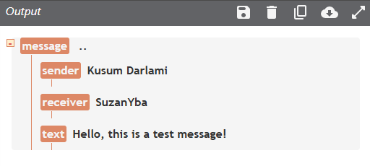
Conclusion:
XML is used to store and transport structured data.

LAB 2: Rules for writing XML
Objective:
- To follow syntax rules for writing well-formed XML.
Steps:
- Ensure all tags are closed.
- Use proper nesting.
- Make tag names case-sensitive.
- Quote all attribute values.
- Include one root element.
Source Code:
<?xml version="1.0" encoding="UTF-8"?>
<contact>
<name>Kusum Darlami</name>
<email>darlamikusum@gmail.com</email>
<phone>9749844496</phone>
</contact>
Output:
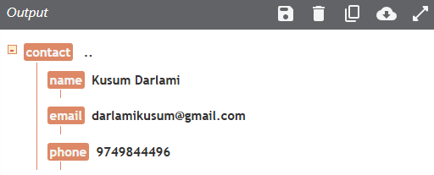
Conclusion:
XML syntax rules ensure the document is well-formed.

LAB 3: Xml tree
Objective:
- To understand the hierarchical (tree) structure of an XML document.
Steps:
- Write an XML file with nested elements.
- Identify the root and child elements.
- Visualize it as a tree.
Source Code:
<?xml version="1.0" encoding="UTF-8"?>
<note>
<from>Sujan Tamang</from>
<to>Kusum Darlami</to>
<subject>Test</subject>
<body>This is a sample note</body>
</note>>
Output:
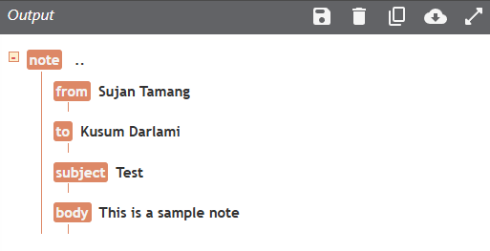
Conclusion:
This lab illustrated that XML is organized in a tree structure where each element can contain sub-elements.

Lab 4: Element
Objective:
- To understand how elements are used in XML to represent structured data.
Steps:
- Create an XML document with nested tags representing data.
- Observe the element syntax and hierarchy.
- Check well-formedness.
Source Code:
<?xml version="1.0" encoding="UTF-8"?>
<notes>
<noteone>
<to>Me</to>
<from>You</from>
</noteone>
<notetwo>
<to>Kusu</to>
<from>Suj</from>
</notetwo>
</notes>
Output:
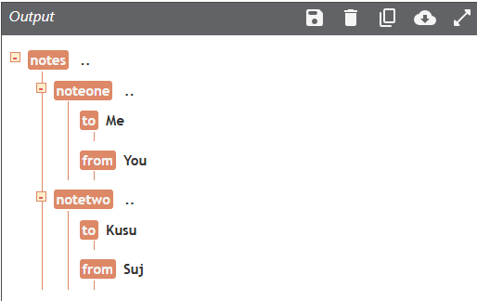
Conclusion:
This lab clarified how XML element’s structure data using tag-based syntax.
Lab 5: Attribute
Objective:
- To explore how attributes provide additional information about XML elements.
Steps:
- Write an XML file with both nested elements and attributes.
- Compare attribute usage to child elements.
- Validate the XML.
Source Code:
<?xml version="1.0" encoding="UTF-8"?>
<note date="12/11/2007">
<to>Muna</to>
<from>Madan</from>
</note>
Output:
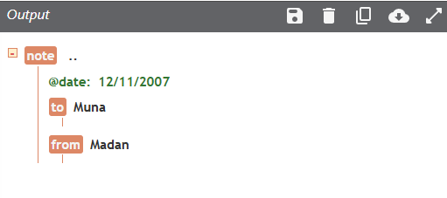
Conclusion:
Attributes in XML provide metadata for elements and offer an alternative to nested tags.

LAB 6: Elements vs Attributes
Objective:
- To use elements and attributes for storing data in XML.
Steps:
- Create a root element.
- Add child elements to store values.
- Use attributes to add metadata to elements.
- Save and validate the XML.
Source Code:
<?xml version="1.0" encoding="UTF-8"?>
<students>
<student id="100" status="active">
<name>Kusum Darlami</name>
<age>20</age>
<program>BCA</program>
</student>
</students>
Output:
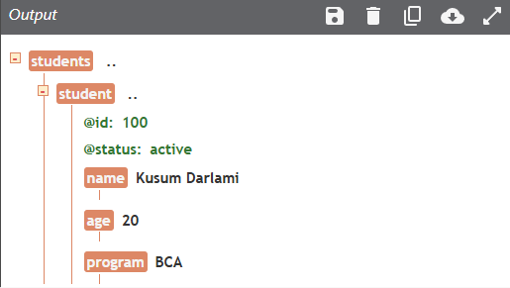
Conclusion:
Elements hold content while attributes describe elements.

LAB 7: XML Namespaces
Objective:
- To avoid element name conflicts using XML namespaces.
Steps:
- Create elements with same names from different domains.
- Declare namespaces using xmlns.
- Qualify elements with prefixes.
- Validate using XML parser.
Source Code:
<?xml version="1.0" encoding="UTF-8"?>
<root>
<h:table xmlns:h="http://www.sujanfruits.com">
<h:tr>
<h:td>Apples</h:td>
<h:td>Bananas</h:td>
</h:tr>
</h:table>
<f:table xmlns:f="https://www.sujanbusiness.com/furniture">
<f:name>African Coffee Table</f:name>
<f:width>80</f:width>
<f:length>120</f:length>
</f:table>
</root>
Output:
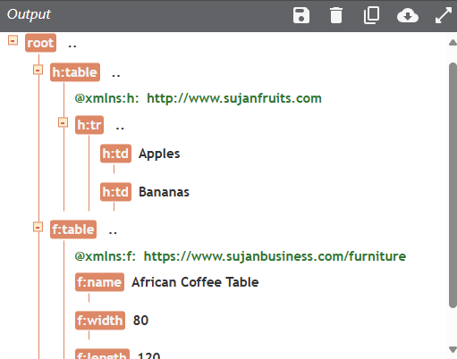
Conclusion:
Namespaces distinguish elements from different vocabularies.
Lab 8: Private external DTDs
Objective:
- To use external DTDs for validating XML documents.
Steps:
- Link an XML file to an external DTD using SYSTEM.
- Define element rules in the DTD.
- Validate the XML using a parser.
Source Code:
<?xml version="1.0"?>
<!DOCTYPE note SYSTEM "note.dtd">
<note>
<to>ram</to>
<from>hari</from>
<heading>Reminder</heading>
<body>Take care of you !!</body>
</note>
Output:
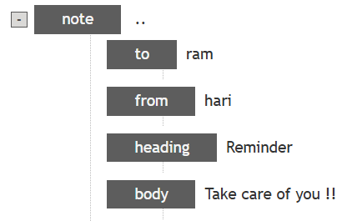
Conclusion:
External DTDs allow for reusable and centralized validation rules for XML files.

Lab 9: Public DTD
Objective:
- To use public DTDs for XML validation.
Steps:
- Include a public DTD reference in the XML declaration.
- Write compliant XML.
- Validate using a parser.
Source Code:
<?xml version="1.0" encoding="UTF-8"?>
<!DOCTYPE note PUBLIC "-//W3C//DTD XHTML 1.0 Strict//EN"
"http://www.w3.org/TR/xhtml1/DTD/xhtml1-strict.dtd">
<note>
<to>you</to>
<from>me</from>
<heading>Reminder</heading>
<body>Don't forget me this weekend!</body>
</note>
Output:
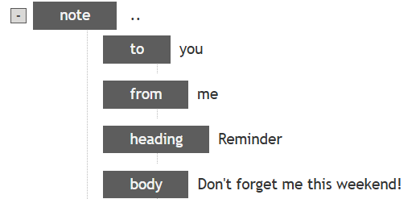
Conclusion:
Public DTDs provide a standard set of rules for XML validation that can be reused by different systems.

Lab 10: Restrictions on Values
Objective:
- To restrict the range of acceptable values in XML schema using minInclusive and maxInclusive.
Steps:
- Create an XSD schema with restrictions on numeric values.
- Validate the XML against the schema.
- Check for boundary value compliance.
Source Code:
<xs:schema xmlns:xs="http://www.w3.org/2001/XMLSchema">
<xs:element name="age">
<xs:simpleType>
<xs:restriction base="xs:integer">
<xs:minInclusive value="0"/>
<xs:maxInclusive value="120"/>
</xs:restriction>
</xs:simpleType>
</xs:element>
</xs:schema>
Output:
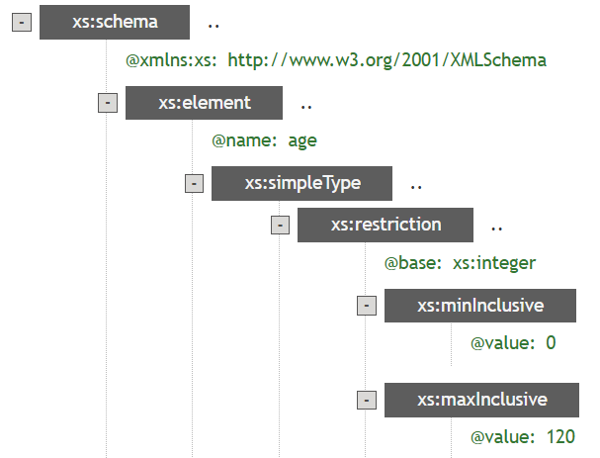
Conclusion:
This lab taught how to enforce numeric constraints within XML schemas.
Lab 11: Restrictions on a Set of Values
Objective:
- To restrict element values to a predefined list using enumeration in XSD.
Steps:
- Define an element in XSD with an enumeration restriction.
- List allowed values.
- Test XML documents for validation.
Source Code:
<xs:schema xmlns:xs="http://www.w3.org/2001/XMLSchema">
<xs:element name="car">
<xs:simpleType>
<xs:restriction base="xs:string">
<xs:enumeration value="Audi"/>
<xs:enumeration value="Golf"/>
<xs:enumeration value="BMW"/>
</xs:restriction>
</xs:simpleType>
</xs:element>
</xs:schema>
Output:
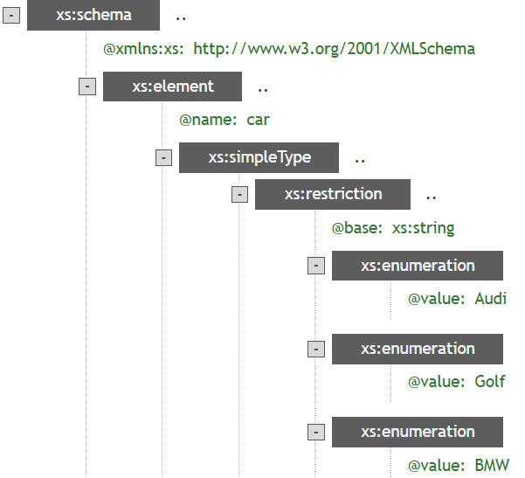
Conclusion:
Enumerations are useful for restricting input values to a fixed set, ensuring data consistency.
Lab 12: Restrictions on a Series of Values
Objective:
- To enforce string format rules using patterns in XML schema.
Steps:
- Define a pattern using regex in XSD.
- Apply it to an element.
- Validate the XML data.
Source Code:
<xs:schema xmlns:xs="http://www.w3.org/2001/XMLSchema">
<xs:element name="letter">
<xs:simpleType>
<xs:restriction base="xs:string">
<xs:pattern value="[a-z]"/>
</xs:restriction>
</xs:simpleType>
</xs:element>
</xs:schema>
Output:
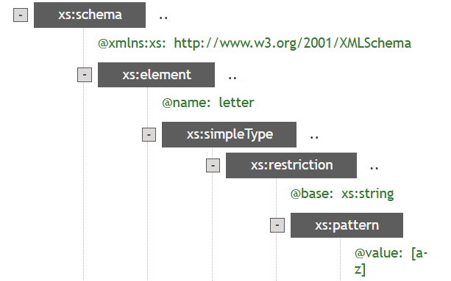
Conclusion:
Patterns help validate string formats such as IDs, names, or codes.
Lab 13: Restrictions on Whitespace Characters
Objective:
- To control whitespace behavior in XML schema using whiteSpace facet.
Steps:
- Add whitespace restriction in XSD.
- Observe how parser treats spaces or line breaks.
- Validate results.
Source Code:
<xs:schema xmlns:xs="http://www.w3.org/2001/XMLSchema">
<xs:element name="person">
<xs:simpleType>
<xs:restriction base="xs:integer">
<xs:whiteSpace value="pre"/>
</xs:restriction>
</xs:simpleType>
</xs:element>
</xs:schema>
Output:
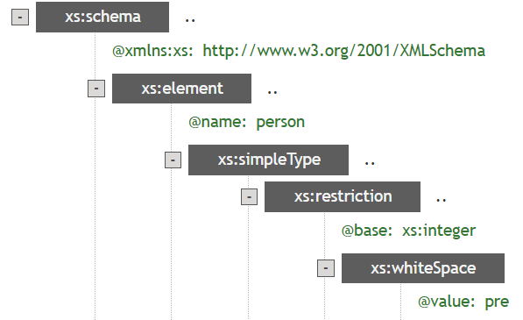
Conclusion:
Whitespace control is important for preserving or normalizing textual content.
Lab 14: Restrictions on Length
Objective:
- To enforce data length constraints in XML schema.
Steps:
- Use length, minLength or maxLength in schema definition.
- Validate with XML inputs.
- Observe validation errors if lengths mismatch.
Source Code:
<xs:schema xmlns:xs="http://www.w3.org/2001/XMLSchema">
<xs:element name="code">
<xs:simpleType>
<xs:restriction base="xs:float">
<xs:length value="9"/>
</xs:restriction>
</xs:simpleType>
</xs:element>
</xs:schema>
Output:
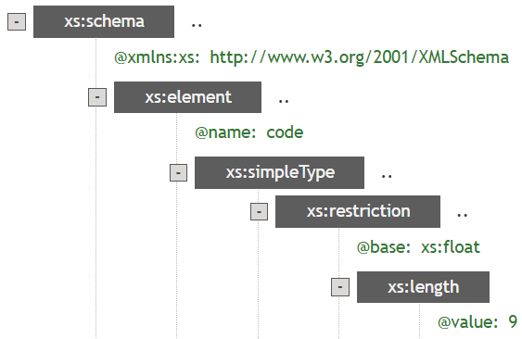
Conclusion:
This ensures data fields adhere to fixed-length requirements like codes, PINs, etc.
Lab 15: Order Indicators
Objective:
- To learn the use of order indicators in XSD: <all>, <choice>, and <sequence>.
Steps:
- Define elements using all indicators.
- Create example XML.
- Validate how they affect ordering.
Source Code:
a) All Indicator
<xs:schema xmlns:xs="http://www.w3.org/2001/XMLSchema">
<xs:element name="person">
<xs:complexType>
<xs:all>
<xs:element name="name" type="xs:string"/>
<xs:element name="surname" type="xs:string"/>
</xs:all>
</xs:complexType>
</xs:element>
</xs:schema>
Output:
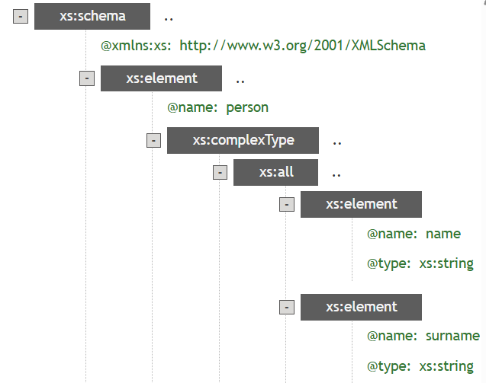
b) Choice Indicator
<xs:schema xmlns:xs="http://www.w3.org/2001/XMLSchema">
<xs:element name="employ" type="xs:string"/>
<xs:complexType name="employ">
<xs:sequence>
<xs:element name="identity" type="xs:int"/>
<xs:element name="dep" type="xs:string"/>
</xs:sequence>
</xs:complexType>
<xs:element name="person">
<xs:complexType>
<xs:sequence>
<xs:element ref="h3" minOccurs="0"/>
<xs:choice>
<xs:element name="staff" type="employ"/>
<xs:element name="worker" type="worker"/>
</xs:choice>
</xs:sequence>
</xs:complexType>
</xs:element>
</xs:schema>

Output:
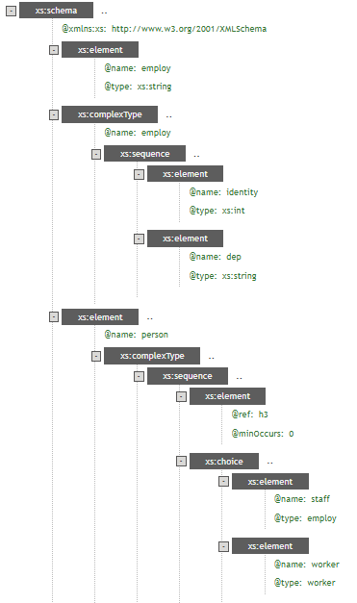

c) Sequence Indicator
<xs:schema xmlns:xs="http://www.w3.org/2001/XMLSchema">
<xs:element name="person">
<xs:complexType>
<xs:sequence>
<xs:element name="name" type="xs:string"/>
<xs:element name="surname" type="xs:string"/>
</xs:sequence>
</xs:complexType>
</xs:element>
</xs:schema>
Output:
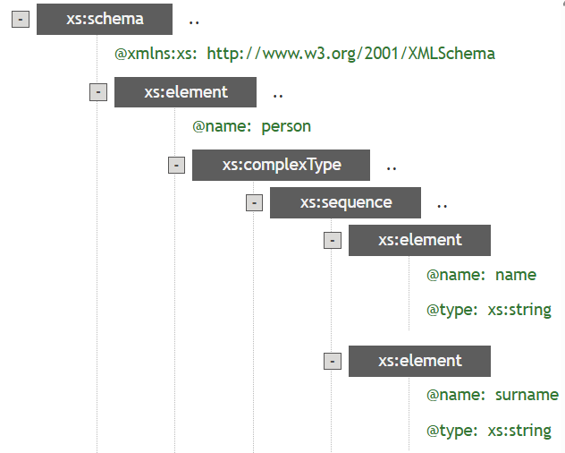
Conclusion:
Order indicators determine how child elements appear — fixed, optional, or unordered.

Lab 16: Occurrence Indicators
Objective:
- To control element repetition using minOccurs and maxOccurs attributes in XSD.
Steps:
- Create an XSD schema with these indicators.
- Write XML with repeated elements.
- Validate how parser enforces occurrence limits.
Source Code:
a) maxOccurs Indicator
<?xml version="1.0" encoding="ISO-8859-1"?>
<xs:schema xmlns:xs="http://www.w3.org/2001/XMLSchema"
elementFormDefault="qualified">
<xs:element name="persons">
<xs:complexType>
<xs:sequence>
<xs:element name="person" maxOccurs="unbounded">
<xs:complexType>
<xs:sequence>
<xs:element name="full_name" type="xs:string"/>
<xs:element name="child_name" type="xs:string" minOccurs="0"
maxOccurs="5"/>
</xs:sequence>
</xs:complexType>
</xs:element>
</xs:sequence>
</xs:complexType>
</xs:element>
</xs:schema>
Output:
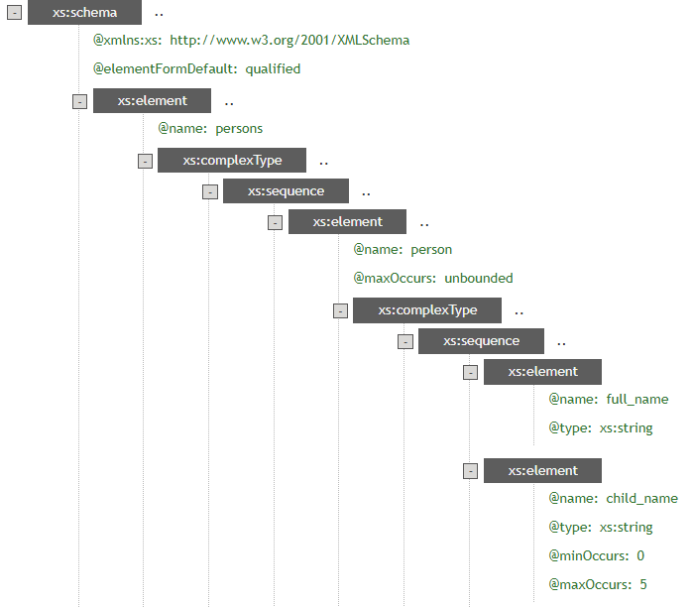

b) minOccurs Indicator
<xs:schema xmlns:xs="http://www.w3.org/2001/XMLSchema">
<xs:element name="person">
<xs:complexType>
<xs:sequence>
<xs:element name="name" type="xs:string"/>
<xs:element name="childrens name" type="xs:string" maxOccurs="8" minOccurs="0"/>
</xs:sequence>
</xs:complexType>
</xs:element>
</xs:schema>
Output:
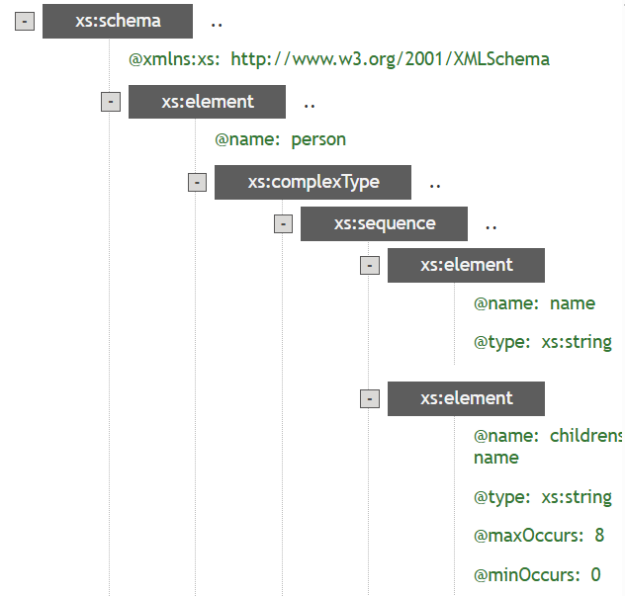
Conclusion:
These indicators help control how many times elements can appear in XML.

Lab 17: Group Indicators
Objective:
- To group related XML elements and attributes using elementGroup and attributeGroup in XSD.
Steps:
- Define groups in schema.
- Reference them inside complex types.
- Observe reusability and structure clarity.
Source Code:
a) Element Groups:
<xs:schema xmlns:xs="http://www.w3.org/2001/XMLSchema">
<xs:group name="persongroup">
<xs:sequence>
<xs:element name="name" type="xs:string"/>
<xs:element name="lastname" type="xs:string"/>
<xs:element name="birth day" type="xs:date"/>
</xs:sequence>
</xs:group>
<xs:element name="person">
<xs:complexType>
<xs:sequence>
<xs:group ref="persons group"/>
</xs:sequence>
</xs:complexType>
</xs:element>
</xs:schema>

Output:
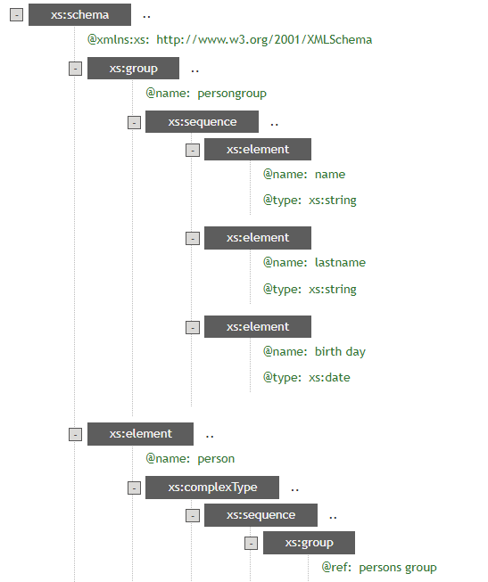
b) Attribute Groups:
<xs:schema xmlns:xs="http://www.w3.org/2001/XMLSchema">
<xs:attributeGroup name="person attrgroup">
<xs:attribute name="name" type="xs:string"/>
<xs:attribute name="surname" type="xs:string"/>
<xs:attribute name="birth day" type="xs:date"/>
</xs:attributeGroup>
<xs:element name="person">
<xs:complexType>
<xs:attributeGroup ref="person attrgroup"/>
</xs:complexType>
</xs:element>
</xs:schema>
Output:
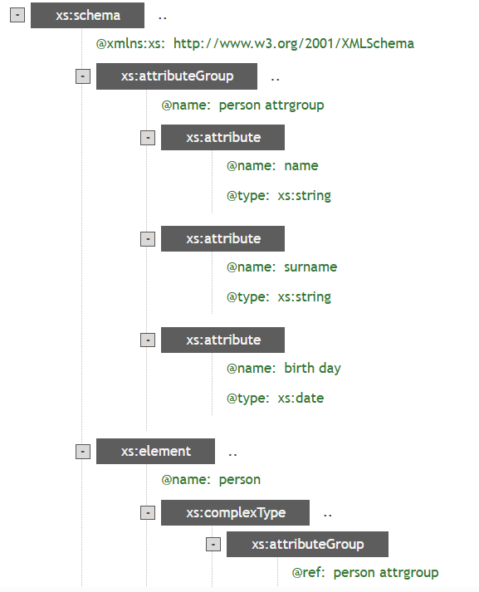
Conclusion:
Grouping simplifies schema design by modularizing similar elements or attributes.

Lab 18: XSLT Code
Objective:
- To transform XML data into HTML using XSLT.
Steps:
- Write an XSLT stylesheet with templates.
- Apply it to an XML file.
- Generate an HTML table from XML data.
Source Code:
<?xml version="1.0" encoding="UTF-8"?>
<xsl:stylesheet version="1.0" xmlns:xsl="http://www.w3.org/1999/XSL/Transform">
<xsl:template match="/">
<html>
<body>
<h2>My collection</h2>
<table border="1">
<tr bgcolor="#9acd32">
<th style="text-align:left">Title</th>
<th style="text-align:left">Artist</th>
</tr> <xsl:for-each select="catalog/cd"> <tr>
<td><xsl:value-of select="title"/></td>
<td><xsl:value-of select="artist"/></td>
</tr>
</xsl:for-each>
</table>
</body>
</html>
</xsl:template>
</xsl:stylesheet>

Output:
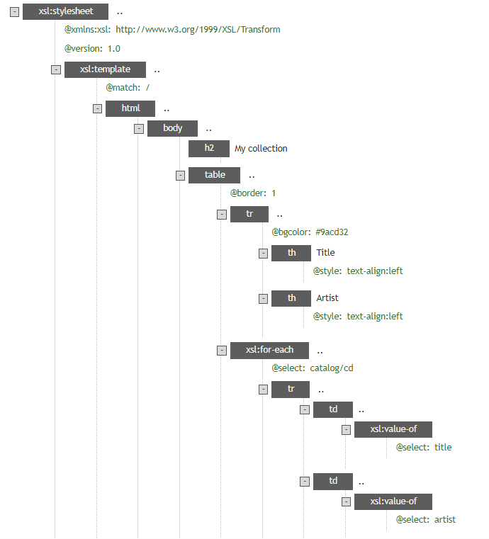
Conclusion:
XSLT allows converting XML into user-friendly formats like HTML.

Lab 19: XPATH Functions
Objective:
- To use XPath to navigate through elements and attributes in XML.
Steps:
- Write an XML document.
- Use XPath queries to select specific nodes.
- Display queried data.
Source Code:
<?xml version="1.0" encoding="UTF-8"?>
<bookstore>
<book>
<title lang="en">lord of rings</title>
<author>J.R.R. Tolkien</author>
<year>1892</year>
<price>19.99</price>
</book>
</bookstore>
Output:
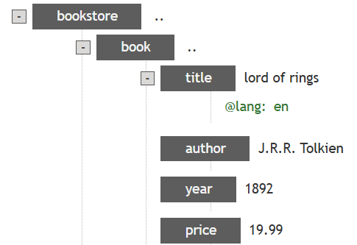
Conclusion:
XPath enables precise querying of XML content based on paths and conditions.
Lab 20: XQuery Functions
Objective:
- To perform querying and sorting on XML data using XQuery.
Steps:
- Load an XML file.
- Use XQuery to extract and order elements.
- Return results in XML or HTML.
Source Code:
<ul>{
for $x in doc("books.xml")/bookstore/book/title
order by $x
return <li>{$x}</li>
}
</ul>
Output:
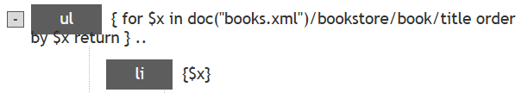
Conclusion:
XQuery is powerful for data extraction and restructuring from XML sources.

Lab 21: XQuery Conditional Expressions
Objective:
- To use XQuery conditional expressions to filter and transform XML data.
Steps:
- Load an XML document.
- Write a conditional XQuery expression.
- Display elements based on their category.
Source Code:
<movies>{
for $x in doc("movies.xml")/moviestore/movie
return
if ($x/@category eq "children") then
<child>{data($x/name)}</child>
else
<adult>{data($x/title)}</adult>
}</movies>
Output:
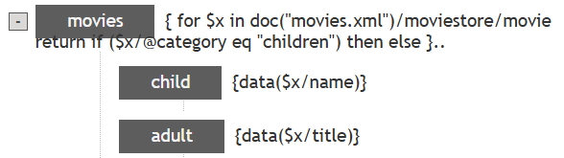
Conclusion:
XQuery allows condition-based selection and transformation of XML data.

LAB 22: XML DOM
Objective:
- To parse XML using the Document Object Model (DOM) in JavaScript.
Steps:
- Create an XML string or file.
- Use DOM methods to read and manipulate elements.
- Output the desired information from the document.
Source Code:
<?xml version="1.0" encoding="UTF-8"?>
<bookstore>
<book category="cooking">
<title lang="en">Everyday Italian</title>
<author>Giada De Laurentiis</author>
<year>2005</year>
<price>30.00</price>
</book>
<book category="children">
<title lang="en">Harry Potter</title>
<author>J K. Rowling</author>
<year>2005</year>
<price>29.99</price>
</book>
</bookstore>

Output:
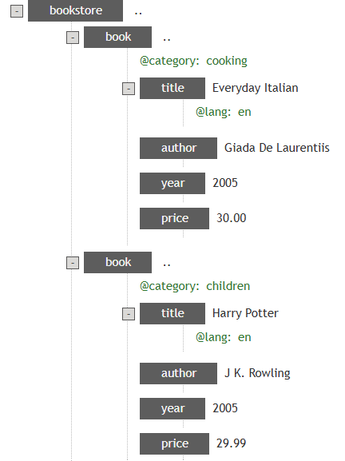
Conclusion:
This lab helped understand how the DOM API is used to navigate and extract data from XML documents.

Lab 23: XML Parser
Objective:
- To parse XML content dynamically using JavaScript and DOMParser.
Steps:
- Write JavaScript code to parse a string of XML.
- Access elements via DOM methods.
- Display selected content.
Source Code:
<!DOCTYPE html>
<html>
<body>
<p id="dome"></p>
<script>
var parser, xmlDoc;
var text = "<bookstore><book>" +
"<title>Everyday Italian</title>" +
"<author>Giada De Laurentiis</author>" +
"<year>2005</year>" +
"</book></bookstore>";
parser = new DOMParser();
xmlDoc = parser.parseFromString(text, "text/xml");
document.getElementById("demo").innerHTML =
xmlDoc.getElementsByTagName("title")[0].textContent;
</script>
</body>
</html>

Output:
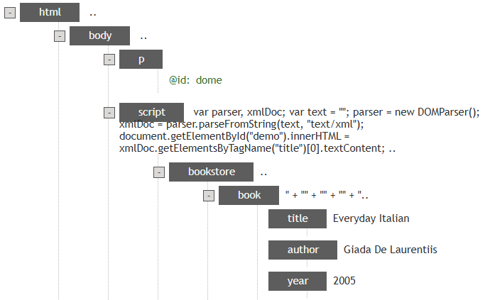
Conclusion:
Client-side XML parsing lets web apps manipulate and render XML data.

